EXP NO 1: CREATE A SIMPLE CLOUD SOFTWARE APPLICATION FOR FLIGHT RESERVATION SYSTEM USING ANY CLOUD SERVICE PROVIDER TO DEMONSTRATE SAAS.

DATE:

AIM:

To create a simple cloud software application for flight reservation system using any cloud service provider to demonstrate saas.

PROCEDURE:

Step1: Go to zoho.com.

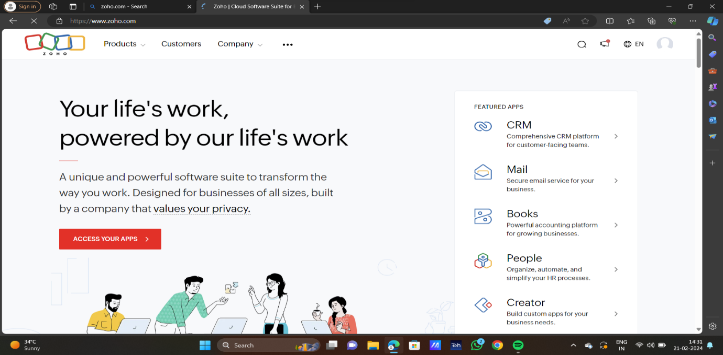

STEP2:LOG INTO THE ZOHO.COM

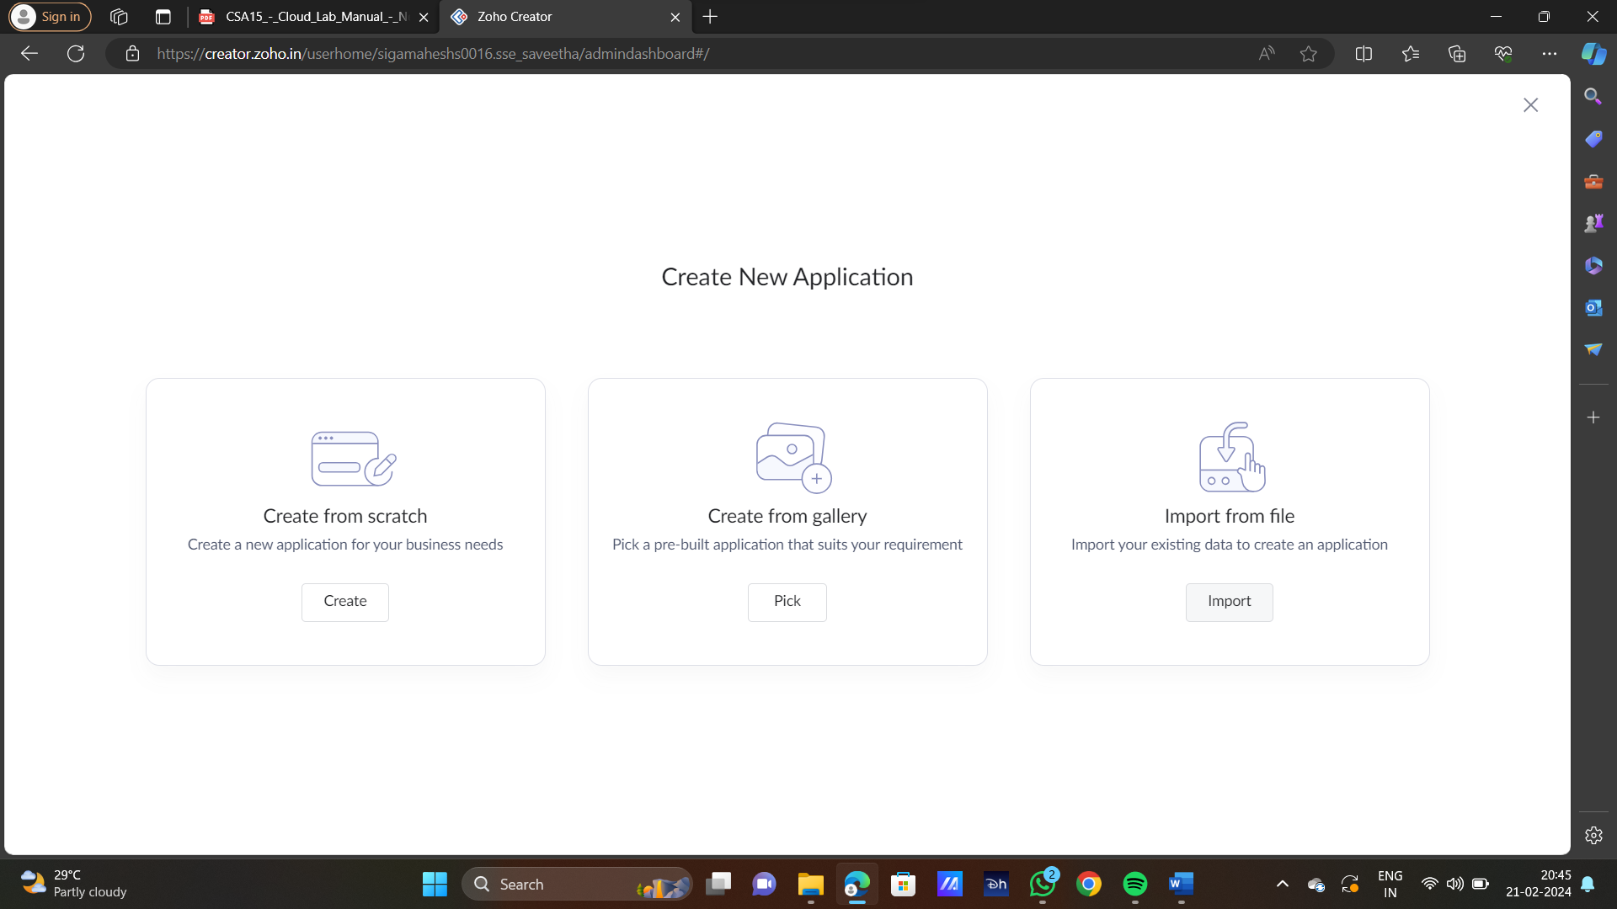

STEP3:SELECT ONE APPLICATION

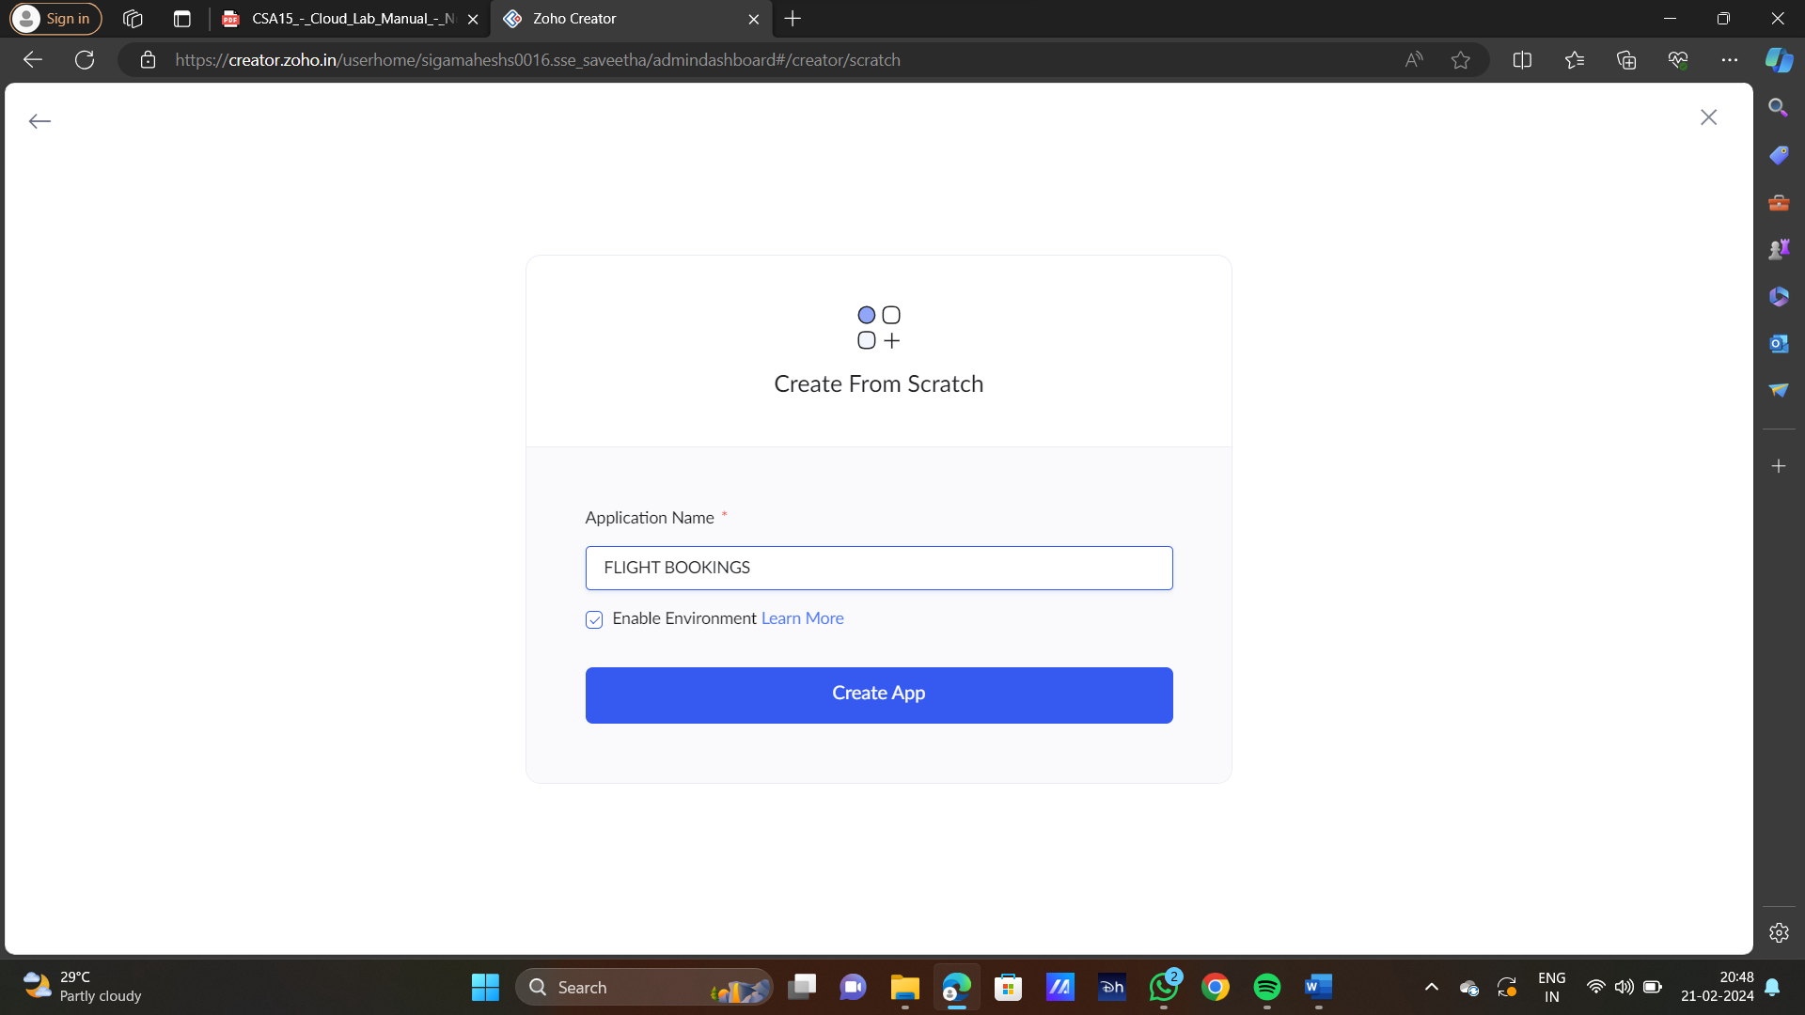

STEP4:ENTER APPLICATION NAME



STEP5:CREATED NEW APPLICATION

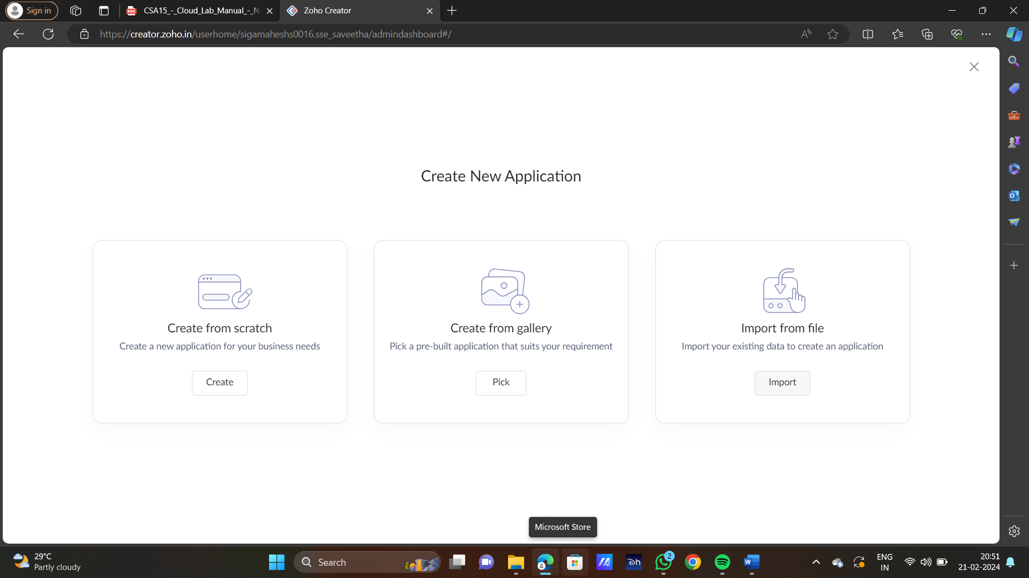

STEP6:SELECT ONE FORM

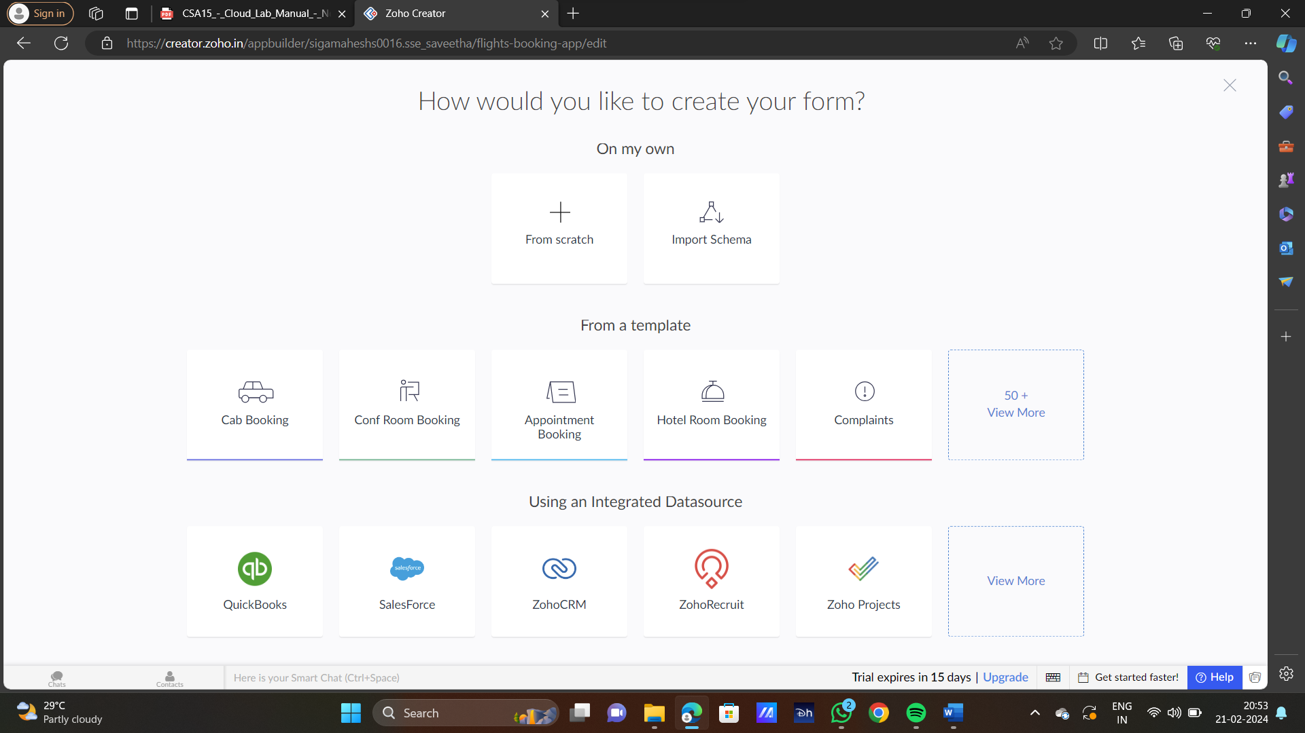

STEP7:THE SOFTWARE HAS BEEN CREATED

